PulmCrit – Treatment of hemodynamically stable new-onset AF in critical illness
November 9, 2015 by Josh Farkas 7 Comments
.

Introduction with a clinical question
.
A 50-year-old woman with no prior medical problems was admitted to Genius General Hospital with severe influenza pneumonia and acute kidney injury. She was transferred to the ICU and treated with high-flow nasal cannula oxygen support. Over time she gradually improved with decreasing oxygen requirements and improving renal function. On hospital day two she developed new-onset atrial fibrillation (AF) with a ventricular rate of 130 b/m. She was symptomatic with palpitations but was hemodynamically stable. What is the best therapeutic approach for her?
.

Defining new-onset AF in critical illness (NAFCI)
.
NAFCI is used here to refer to patients with no prior history of AF who are admitted in sinus rhythm and subsequently develop new-onset AF while being treated for critical illness, generally in the ICU. The main differential diagnostic consideration is previously undiagnosed asymptomatic paroxysmal AF. Features that would support a diagnosis of NAFCI rather than chronic, paroxysmal AF may include symptomatic AF or severe physiologic stress triggering transition into AF (e.g. AF immediately following an epinephrine bolus).
.
NAFCI is common in critically ill patients with an incidence of ~10%, but little is known about its treatment (Yoshida 2015). Unfortunately, our understanding of AF treatment is based almost exclusively on studies ofoutpatients with chronic, recurrent AF occurring spontaneously – which is the polar opposite of NAFCI.
.

Arguments for attempting rhythm control
.
Available evidence regarding rate vs. rhythm control is derived from outpatients, where there is equipoise between these two strategies. Given that NAFCI patients often have transient AF due to acute stress, there may be a stronger rationale for attempting rhythm control in NAFCI compared to spontaneous AF. Additional arguments in favor of attempting rhythm control include:
.

Minimizing stroke & hemorrhage risks?
.
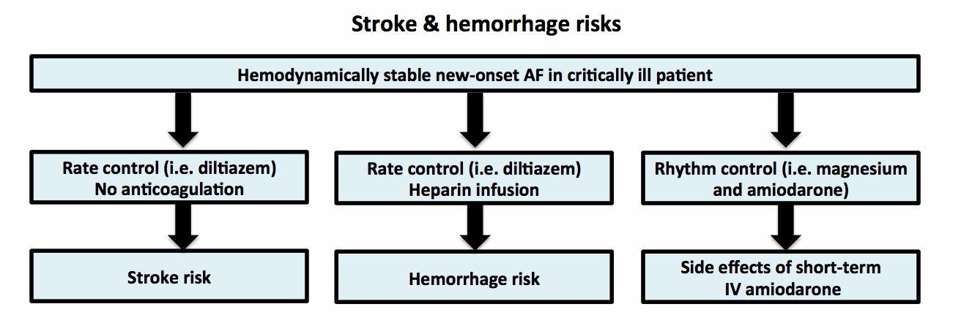
.
Perhaps the strongest argument for a rhythm-control strategy may be to avoid risks of stroke or anticoagulation. NAFCI is associated with a 2% risk of in-hospital ischemic stroke among patients with severe sepsis (Walkey 2011). High stroke rates may reflect hypercoagulability due to systemic inflammation.
.
Anticoagulation is usually recommended to reduce stroke risk for patients in AF >48 hours. Unfortunately, critically ill patients also have high rates of hemorrhage when anticoagulated for AF. Consequently, some authors have challenged the broad use of anticoagulation (Labbe 2015). There is no consensus about this: The rate of anticoagulation varies between 3% and 57% at different centers (Champion 2014, Koyfman 2015).
.
Realistically, the efficacy of anticoagulation among these patients is low. Most studies report that below one third of patients receive anticoagulation. Even when anticoagulation is provided, it may need to be interrupted and the level of anticoagulation may often be sub therapeutic. In this context, a prompt and effective rhythm control strategy might reduce the risk of stroke and other arterial thromboembolic events (e.g. mesenteric ischemia, limb ischemia).
.
Rhythm control has failed to prevent stroke among outpatients, possibly due to the occurrence of subclinical episodes of AF. NAFCI differs from outpatient AF because it presents a unique opportunity to pursueimmediateand definitive rhythm control (e.g., critically ill patients on telemetry cannot have occult episodes of AF). Unfortunately, there is no evidence regarding the effect of a rhythm control strategy on stroke among NAFCI (1).
.

Improved mortality?
.
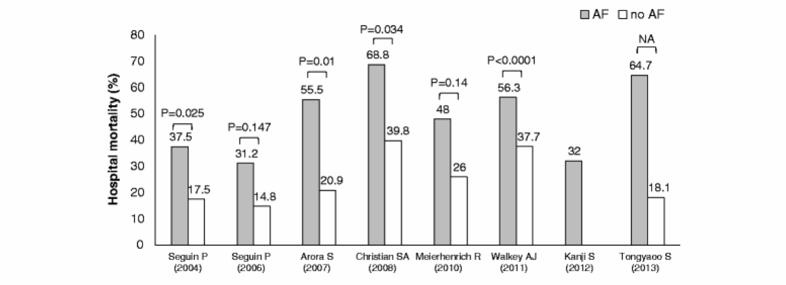
NAFCI is consistently associated with increased mortality, often as an independent risk factor (figure above;Yoshida 2015). Similarly, patients who are cardioverted to sinus rhythm have a lower mortality than patients in whom cardioversion fails (Meier enrich 2010). This may merely be a correlation, because NAFCI is associated with increased age, illness severity, and comorbidity. However, causality is also possible. Even if AF doesn’t cause obvious hemodynamic instability, reduced cardiac function might impair the patient’s ability to cope with critical illness. For example, in the setting of kidney injury, reduced renal perfusion could be harmful. In the setting of ARDS, AF might increase pulmonary venous pressure, exacerbating pulmonary edema.
.

Reduced risk of future AF?
.
“Allowing patients to remain in AF for weeks to months will increase their risk for developing long-standing persistent AF”
– Bhave 2013
.
The longer a patient is in AF, the harder it is to transition back to normal sinus rhythm. Hence the clinical adage, “atrial fibrillation begets atrial fibrillation.” The technical term for this process is electrical remodeling of the atria, which begins within minutes of transitioning into AF (Goette 1996).
.
With the resolution of critical illness, most patients will spontaneously revert to sinus rhythm. However, some may not. It is possible that prompt cardioversion, prior to electrical remodeling, might reduce the likelihood of developing persistent atrial fibrillation or future paroxysms of AF (2).
.

Strategy for cardioversion and maintence of sinus rhythm
.
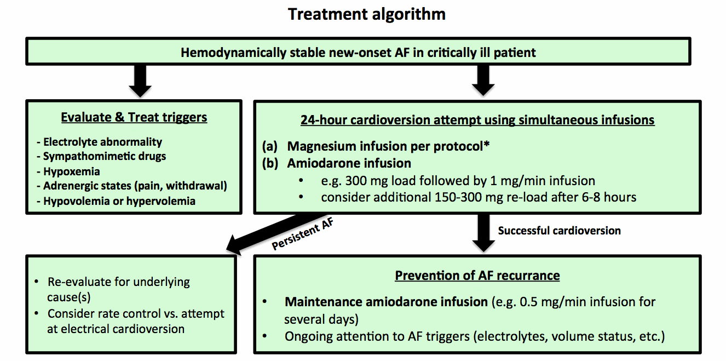
*Magnesium infusion protocol located here.
.

[1] Act quickly
.
The ideal timing of cardioversion is immediately after initiation of AF. AF causes electrical remodeling of the atrium which may make cardioversion more difficult over time. Thus, it is conceivable that a “golden hour” (or some time window) may exist following new-onset AF during which cardioversion would be most successful. Additionally, minimizing the duration of atrial fibrillation should reduce the risk of stroke (contrary to classic teaching, there is a tiny risk of forming thrombi before 48 hours; Airaksinen 2013).
.

[2] Investigate and remove triggers if possible
.
Any precipitating factors should be addressed (i.e., electrolyte abnormalities, catheter irritation of the atria, sympathomimetic drugs, hypoxemia, adrenergic states such undertreated pain/agitation or alcohol withdrawal). AF may be promoted by hypovolemia or volume overload, so volume status should be optimized. For patients who are on vasopressors, transitioning to agents with less beta-adrenergic activity may be considered.
.

[3] Cardiac magnesium infusion
.
This was explored in detail last week. Magnesium is a very safe therapy, which may improve rhythm control. For patients with intact renal function (e.g. GFR>30 ml/min), a magnesium infusion is needed to maintain high serum levels of magnesium and replete intracellular magnesium stores.
.
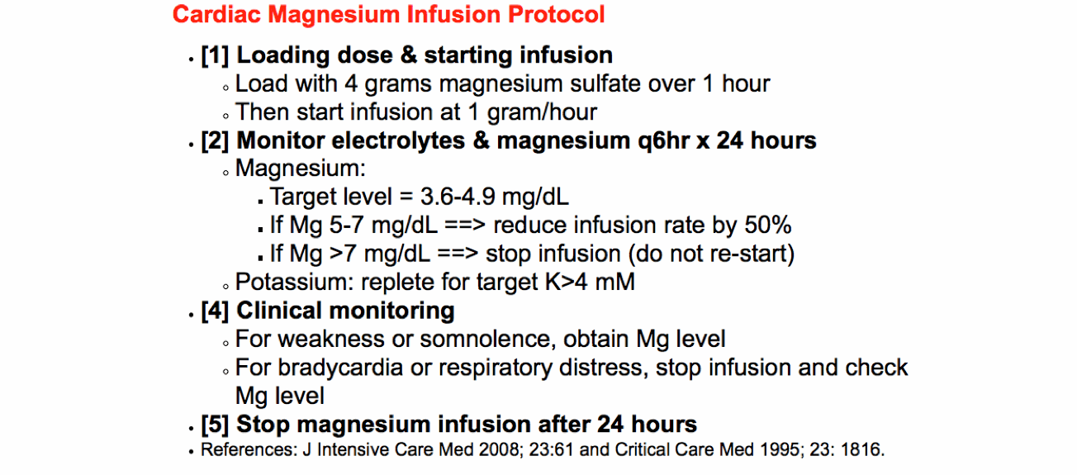
.
Sleeswijik 2008 described the use of magnesium alone initially, with amiodarone reserved for patients who fail to respond to magnesium. However, evidence supporting this strategy is limited. Currently it may be reasonable to start both amiodarone and magnesium immediately, with magnesium functioning as an adjunctive agent. Magnesium appears to work synergistically with amiodarone and other class-III antiarrhythmic agents (Cagli 2006, Ganga 2013).
.

[4] Amiodarone
.
Amiodarone is widely used among critically ill patients for several reasons. It promotes both cardioversion and maintenance of sinus rhythm. It rarely causes hypotension or secondary arrhythmias (e.g. torsade de pointes).
.

Pharmacology: Amiodarone for cardioversion
.
There are a wide range of doses reported for cardioversion of new AF, with little evidence comparing different doses. A typical regimen is loading with 300 mg followed by an infusion at 1 mg/minute for 24 hours.
.
A potential drawback to this regimen is that it will produce falling serum levels of amiodarone after the initial bolus. To counteract this, some authors have utilized a larger, tapering loading dose, which achieved a 92% conversion rate (e.g. 300 mg over one hour followed by 540 mg over the next three hours; Hou 1995). A simpler approach may be to administer an additional 150 mg amiodarone once or twice if the patient doesn’t cardiovert within 6-8 hours. Delayed re-loading occurs after the cardiac myocytes have absorbed magnesium, which might render them more responsive to amiodarone:
.
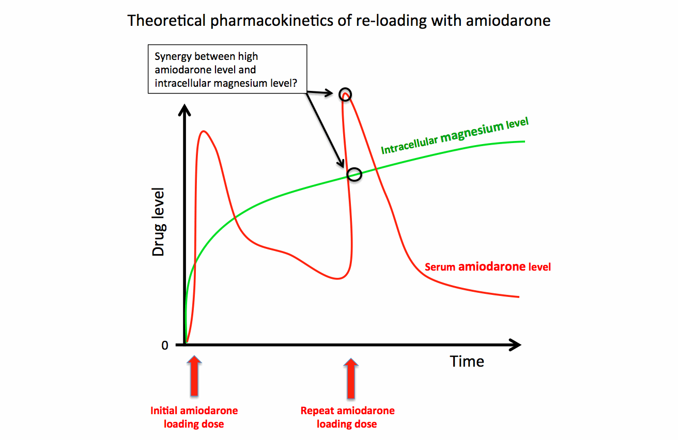
.

Pharmacology: Amiodarone for maintenance of sinus rhythm
.
The half-life of amiodarone depends on how long it has been administered. When used chronically, the half-life is extremely long. This fuels a common misconception that amiodarone can be stopped with no immediate clinical consequence. However, when it is first initiated, the half-life of a single intravenous dose is 18-36 hours (Hughes 2000). Therefore, premature discontinuation of amiodarone may lead to recurrent AF.
.
A multicenter Canadian study found that although 87% of patients could be cardioverted with amiodarone, 42% reverted back to AF during their ICU stay (Kanji 2012). To prevent recurrence, it seems reasonable to continue amiodarone for some period of time while the patient stabilizes (e.g., perhaps up to a week, depending on how rapidly the patient improves). This is similar to the accepted concept of using a short course of amiodarone for primary prevention of AF in patients undergoing cardiac surgery. When amiodarone is discontinued following several days of therapy it will have a longer half-life, providing some ongoing protection against recurrent AF.
.

Safety of amiodarone
.
Amiodarone is notorious for causing numerous complications (e.g. thyroid, lung, and eye disease). However, these complications only result from chronicaccumulation of amiodarone following months to years of treatment (Desai 1997).
.
Overall, the short-term use of intravenous amiodarone is well tolerated. The side-effect profile includes bradycardia, hypotension, and infusion-site phlebitis. Concerns have been raised about the possibility of acute-onset pulmonary toxicity, but this appears to be a myth (3). The risks of short-term intravenous amiodarone are likely lower than the risks of heparin anticoagulation or stroke from AF.
.
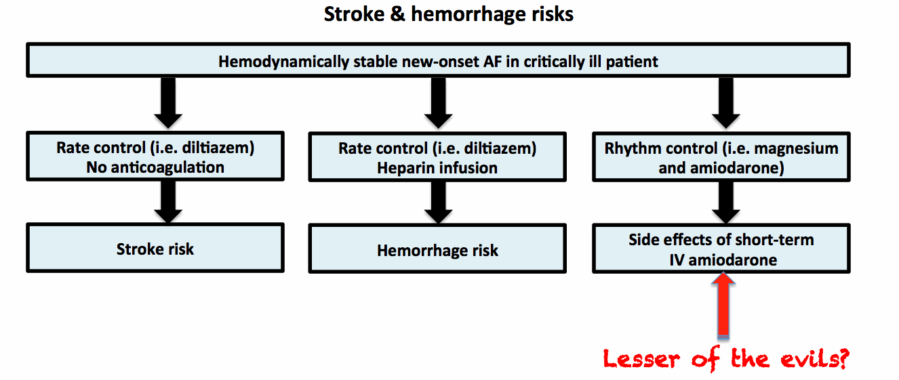
.

[5] Patients failing to cardiovert
.
Magnesium and amiodarone are both effective for rate control as well as rhythm control. Thus, even if patients fail to cardiovert, it is very likely that they will achieve adequate rate control (Karth 2001). Whether further efforts to achieve cardioversion (e.g. electrical cardioversion) are worthwhile is unclear, and may be judged on a case-by-case basis.
.

Resolution of the case
.
Our patient was started on magnesium and amiodarone infusions, with conversion to normal sinus rhythm a few hours later. Amiodarone was continued until she improved further and left the ICU a few days later. She was discharged from the hospital with normal renal function, normal sinus rhythm, and ongoing improvement in her pulmonary status.
.

- New-onset AF is common among critically ill patients, but very little is known about its treatment.
- New-onset AF correlates with increased stroke rate, ICU length of stay, and mortality. However, it is unknown whether AF causes increased mortality.
- Theoretical arguments favoring an attempt at rhythm control include improved cardiac function, reduced stroke risk, and reduced risk of persistent AF.
- Combining magnesium and amiodarone yields a high rate of cardioversion among new-onset AF.
- Although amiodarone has substantial long-term toxicity, short courses of intravenous amiodarone are well tolerated.

Notes
(1) There are three theoretical reasons for anticoagulation in AF:
- (a) Prevention of thrombus formation in a patient with ongoing AF.
- (b) Resolution of existing thrombus prior to cardioversion (for a patient who has been in AF >48 hours, anticoagulation may be performed for 4 weeks prior to cardioversion)
- (c) Prevention of new thrombus formation aftercardioversion. AF causes an atrial tachymyopathy, so even after conversion to sinus rhythm the atria may not contract effectively for 1-2 weeks. Thus, for a patient who has been in AF >48 hours, anticoagulation is advisable following conversion to sinus rhythm.

For a patient with NAFCI, prompt cardioversion (ideally <24 hours after the onset of AF) with sustained rhythm control should avoid the need for anticoagulation for any of these three reasons.
(2) Even among patients who spontaneously convert back to sinus rhythm, there is a significant risk of future episodes of AF following discharge. These episodes of AF may be subclinical, presenting initially with stroke (Walkey 2014). Although some authors have proposed the use of post-discharge holter monitoring, this remains a challenging clinical problem. If prompt control of AF within the hospital could reduce the risk of recurrent episodes outside the hospital, this would be of great value.
(3) Some concern has been raised regarding the possibility of acute-onset pulmonary toxicity within days of initiating amiodarone. The strongest support for this concept is a RCT evaluating the role of amiodarone in preventing AF among patients undergoing lung resection (Mieghem 1994). The study was stopped prematurely due to three patients who developed respiratory failure following amiodarone and right pneumonectomy, even though this difference was not statistically significant. Respiratory failure following right pneumonectomy is not uncommon, so it is entirely possible that this occurrence may have been due to chance.
Subsequently, there have been a handful of case reports describing acute-onset respiratory failure following amiodarone initiation, typically in the setting of complex patients undergoing multiple interventions. This evidence doesn’t allow us to either prove or disprove whether acute-onset amiodarone lung toxicity is a real entity. Amiodarone pulmonary toxicity is a diagnosis of exclusion. The pathologic pattern of amiodarone exposure (foamy macrophages) may be found in patients taking amiodarone without clinical lung disease, so even a complete autopsy cannot determine whether the patient had amiodarone pulmonary toxicity.
Upon reviewing the literature, it appears that acute-onset amiodarone pulmonary toxicity may be a “trashcan diagnosis:” a diagnostic label which has been affixed to patients with unexplained respiratory failure and a variety of radiographic and pathologic features. It is possible that these patients may have been suffering from other causes of respiratory failureincluding pneumonia, aspiration pneumonitis, and various idiopathic interstitial pneumonias (Lee 2012, Boriani 2012, Kharabsheh 2002).
Perhaps most notably, recent RCTs involving amiodarone have failed to detect acute pulmonary toxicity. This led the American Association of Thoracic Surgery 2014 guidelines for postoperative AF to conclude that “In the nonsurgical population, it is commonly accepted that amiodarone-related pulmonary toxicity does not occur with short term (<1 month) exposure.”
There is similar concern regarding the possibility of acute amiodarone-induced hepatic failure. To date there are perhaps eleven credible case reports in the literature describing this complication (Stratton 2015). If this is a real phenomenon, it seems to be extremely rare.

