Pulmonary Hypertension Teaching Script

- Primary elevation of pressure in the pulmonary arterial system (pulmonary arterial hypertension), or secondary to elevations of pressure in the pulmonary venous and pulmonary capillary systems (pulmonary venous hypertension)
- Defined by a mean pulmonary arterial pressure (mPAP) >/= 25 mmHg at rest or >/= 30mmHg with exertion. Normal mPAP </= 20mmHg

Classification:

1. Pulmonary Arterial HTN (PAH) | 1.1: Idiopathic PAH  1.2: Heritable  1.2.1: BMPRP  1.2.2: ALK1, endoglin, SMAD9, CAV1, KCNK3  1.2.3: Unknown  1.3: Drug and Toxin induced  Ex: appetite suppressants (aminorex, fenfluramine, dexfenfluramine, diethylproprion), benflurorex, cocaine, methamphetamines, St. John’s Wort, dasatinib, interferon  1.4: Associated with  1.4.1: Connective tissue diseases  1.4.2: HIV  1.4.3: Portal HTN  1.4.4: Congenital heart disease  1.4.5: Schistosomiasis  1’: Pulmonary veno-occlusive disease (PVOD) and/or pulmonary capillary hemangiomatosis (PCH)  1”: Persistent pulmonary HTN of the newborn
2. Secondary to LHD | 2.1: Left ventricular systolic dysfunction  2.2: Left ventricular diastolic dysfunction  2.3: VHD  2.4: Congenital/acquired left heart inflow/outflow tract obstruction and congenital cardiomyopathies
3. Secondary to lung disease and/or hypoxia | 3.1: Chronic obstructive pulmonary disease  3.2: ILD  3.3: Other pulmonary disease with mixed restrictive/obstructive pattern  3.4: Sleep-disordered breathing  3.5: Alveolar hypoventilation disorders  3.6: Chronic exposure to high altitude  3.7: Developmental abnormalities
4. Chronic thromboembolic pulmonary HTN (CTEPH)
5. Unclear multifactorial | 5.1: Hematologic- chronic hemolytic anemia, myeloproliferative disorders, splenectomy  5.2: Systemic- sarcoidosis, pulmonary Langerhans cell histiocytosis: lymphangioleiomyomatosis, neurofibromatosis, vasculitis  5.3: Metabolic-thyroid disorders, glycogen storage disease, Gaucher disease  5.4: Others-tumoral obstruction, fibrosis mediastinitis, chronic renal failure, segmental PHTN

Pathogenesis:

- Group1 PAH is a proliferative vasculopathy of small muscular pulmonary arterioles characterized by medial hypertrophy, intimal hyperplasia as well as by plexiform lesions.
- Group 2-5 less understood and varied depending on the cause, but owing in part to vascular remodeling and increased pulmonary vascular resistance.

Clinical Manifestations:

- slow, insidious onset of vague symptoms such as exertional dyspnea, angina, fatigue, syncope, palpitations, peripheral edema
- Common PE findings: Increased intensity of pulmonic component of second heart sound, right ventricular heave, pulmonary TR murmur, signs of RV failure (raised JVP, hepatomegaly, ascites, peripheral edema, anasarca), cyanosis, or digital clubbing may be present.

Diagnosis:

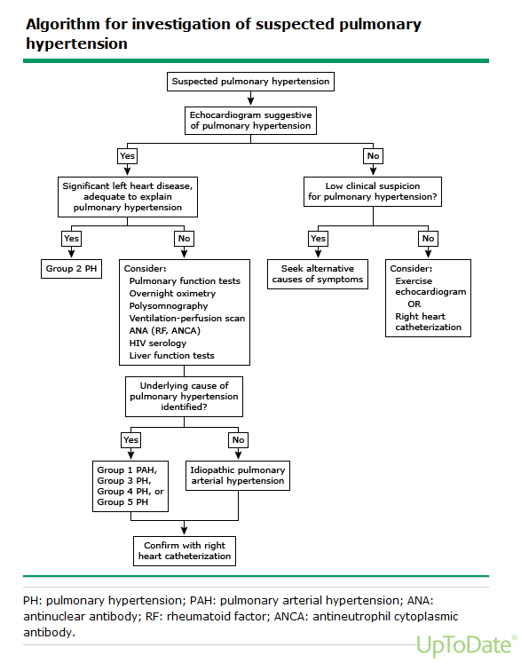

- RHC (gold standard): mPAP>25, PCWP<15, LVEDP<15
- If ILD is suspected, HRCT should be considered
- 6MWT to determine WHO functional class:

Class | WHO functional classification
I | No limitations of physical activity. Ordinary physical activity does not cause undue fatigue or dyspnea, chest pain, or heart syncope
II | Slight limitations. Comfortable at rest. Ordinary physical activity result in undue fatigue or dyspnea, chest pain, or heart syncope
III | Marked limitation of physical activity. Comfortable at rest. Less than ordinary physical activity result in undue fatigue or dyspnea, chest pain, or heart syncope
IV | Inability to carry on any physical activity without symptoms. Manifest signs of RHF. Dyspnea and/or fatigue may be present at rest. Discomfort increased with physical activity

Treatment:

- The treatment of patients with group 1 pulmonary arterial hypertension (PAH) is different from that of the other groups who are, in general, less amenable to advanced
PAH-specific medical therapy. Primary therapy should be directed at the underlying cause of the PH.
- The disease severity should be reassessed following primary therapy, in order to determine whether advanced therapy is indicated.

All Groups:
- Several therapies should be considered in all groups with PH. These include diuretics, oxygen therapy (cornerstone therapy for group 3 PH), anticoagulation (indicated for all patients in group 4 and occasionally in patients in group 1), exercise training, and vaccinations
- A strict 4g sodium/1500ml fluid restriction diet should be followed in all patients.
- Patients should be aware of their “dry weight” and keep record of weights at home in order to detect signs of decompensated HF early.

Advanced Therapy:
- Often referred to as “pulmonary vasodilator therapy” is considered for patients who have WHO functional class II, III, or IV PHTN despite adequate primary therapy. It is widely used for patients with group 1 PAH and administered on case-by-case basis for groups 3-5 and in a few situations for group 2.
- Advanced therapy for group 1 PAH results in improved survival, 6MWT, functional class, and pulmonary hemodynamics, as well as delayed time to disease progression

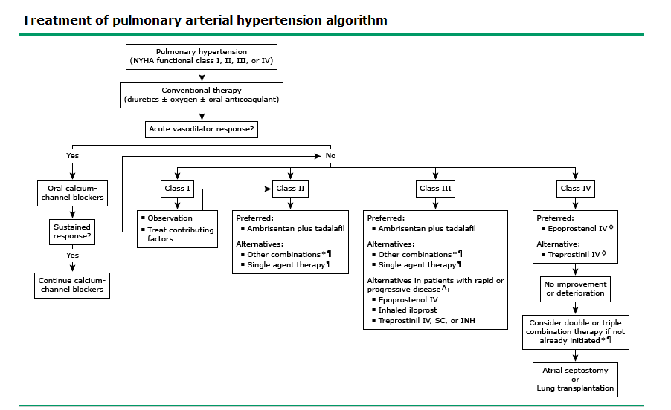

Characteristics of medications used in the treatment of pulmonary hypertension:

Drug | MOA | Common side effects
Prostacyclin pathway agonists  Epoprostenol (IV)  Treprostinil (IV, SC, inhaled)  Iloprost (inhaled)  Selexipag (oral) | Binds endothelial prostacyclin receptors which raises cAMP levels leading to activation of protein kinase A, inhibition of myosin light-chain kinase and therefore smooth muscle relaxation and vasodilation | Jaw pain, diarrhea, flushing, arthralgias
Endothelin receptor antagonists  Bosentan (oral)  Ambrisenten (oral)  Macitentan (oral) | Antagonizes endothelin-1 which is a potent vasoconstrictor and smooth muscle mitogen | Hepatotoxicity, peripheral edema, potent teratogen (contraindicated in pregnancy)
Nitric oxide-cyclic guanosine monophosphate enhancers  Soluble guanylate cyclase stimulant  Riociguat (oral)  Phospodiesterase type 5 inhibitor  Sildenafil (oral, IV)  Tadalafil (oral) | Sensitizes and stimulates binding of sGC to NO, increasing cGMP production and subsequent vasodilation  Prolongs the vasodilatory effect of nitric oxide | Headache, dyspepsia, diarrhea  Headache, dyspepsia, myalgia, nasal congestion

Group 2:
- Treatment of underlying heart disease directed under the care of a cardiologist.

Group 3:
- Treatment of the underlying cause of hypoxemia and correction of hypoxemia with supplemental oxygen.

Group 4:
- Anticoagulation is the primary medical therapy.
- Surgical thromboendarterectomy for selected patients.

