ILD Teaching Script

- Diffuse parenchymal lung diseases collectively referred to as interstitial lung diseases (ILDs), which are a heterogeneous group of disorders classified together because of similar clinical, radiographic, physiologic, or pathologic manifestations
- Divided into those that are associated with known causes and those that are idiopathic
- Most common identifiable causes are exposure to occupational and environmental agents (ex: silica, talc, mica, beryllium, coal dust, fungi, animal proteins, etc) drug-induced pulmonary toxicity (minocycline, rituximab, bleomycin, methotrexate, etc), and radiation-induced lung injury
- ILD can complicate the course of most of the CTDs (ex: polymyositis/dermatomyositis, RA, SLE, scleroderma, mixed connective tissue disease)
- Idiopathic causes include sarcoidosis, cryptogenic organizing pneumonia, and the idiopathic interstitial pneumonias (idiopathic pulmonary fibrosis (usual interstitial pneumonia), desquamative interstitial pneumonia, respiratory bronchiolitis-interstitial lung disease, acute interstitial pneumonia, and nonspecific interstitial pneumonia)

Classification:

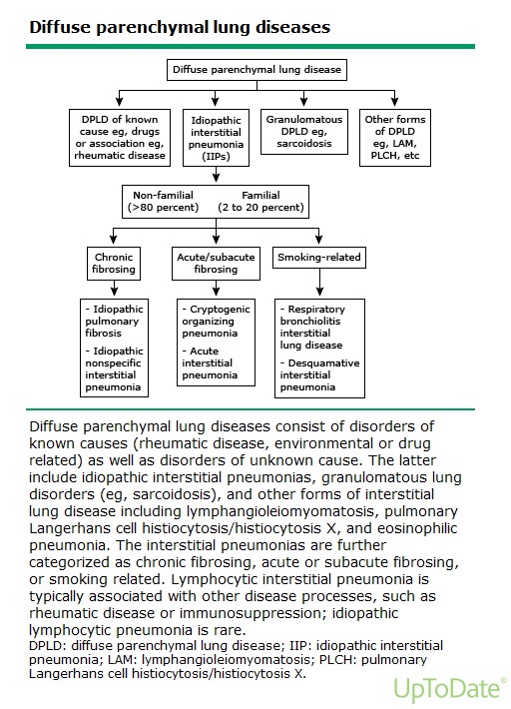
Clinical Manifestations:
- Patients often present with a number of nonspecific symptoms, and it is important to ascertain the duration, severity, and progression of symptoms. Patients should always be asked about extrapulmonary symptoms that might suggest a systemic disorder
- Common symptoms included dyspnea, cough (usually non-productive), hemoptysis, myalgias, arthralgias, weakness, fatigue, fever, photosensitivity, and dry eyes or mouth.
- PE findings can include: crackles, scattered late inspiratory high-pitched rhonchi, findings of pulmonary hypertension, if present, digital clubbing, alopecia, angiofibromas, cutaneous sarcoidosis, joint inflammation, peripheral neuropathy, sclerodactyly, etc.

Diagnosis:
- A thorough history is the most important step in the investigation of ILD
LABS:
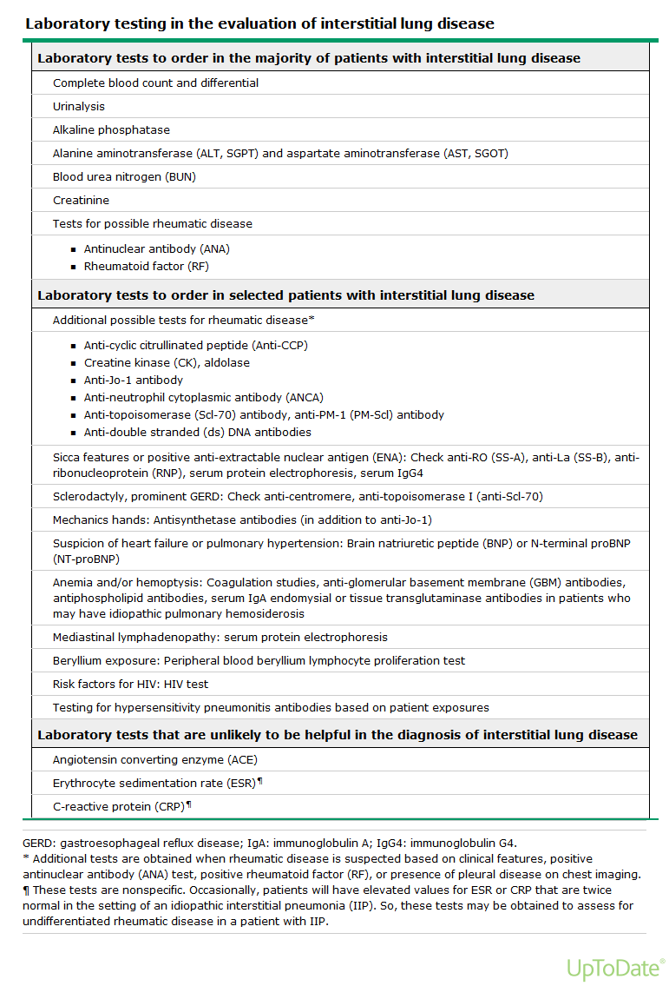
IMAGING:
- Most common CXR abnormality is a reticular pattern; however, nodular or mixed patterns (alveolar filling and increased interstitial markings) can be seen as well as a normal radiograph on 10 percent
- High resolution computed tomography (HRCT) should be obtained in almost all patients with diffuse pulmonary parenchymal disease as it provides greater diagnostic accuracy than the plain chest radiograph.

Some findings and differential include:
Bilateral symmetric hilar adenopathy and upper lung zone reticular opacities suggest sarcoidosis or another granulomatous disease.
Pleural plaques with linear calcification in association with a basilar predominance of reticular opacities suggest asbestosis
Centrilobular nodules that spare the subpleural region are seen in hypersensitivity pneumonitis, sarcoidosis, Langerhans cell histiocytosis and also respiratory, follicular, and cellular bronchiolitis.
Irregular cysts associated with nodules in the upper and middle lung zones suggest pulmonary Langerhans cell histiocytosis.
Basal and peripheral reticular opacities, traction bronchiectasis, and honeycombing (clustered airspaces 3 to 10 mm in diameter) in a subpleural location are the classic features associated with a histopathologic pattern of usual interstitial pneumonitis (UIP). A UIP pattern is seen in idiopathic pulmonary fibrosis, chronic hypersensitivity pneumonitis, and ILD-associated with rheumatoid arthritis.
PULMONARY FUNCTION TESTING:
- Complete PFTs and resting and exercise pulse oximetry should be obtained.
- Most have a restrictive defect with reductions in total lung capacity (TLC), functional residual capacity (FRC), and residual volume (RV). Forced vital capacity (FVC) and forced expiratory volume in one second (FEV1) are decreased, but usually the changes are in proportion to the decreased lung volumes; thus, the FEV1/FVC ratio is usually normal or increased. A reduction in DLCO is also a common and nonspecific finding.
- Patients with interstitial pattern on chest radiograph accompanied by obstructive airflow limitation (ie, a reduced FEV1/FVC ratio) on lung function testing is suggestive of sarcoidosis, Lymphangioleiomyomatosis, Hypersensitivity pneumonitis, Pulmonary Langerhans cell histiocytosis, Tuberous sclerosis and pulmonary lymphangioleiomyomatosis, Combined chronic obstructive pulmonary disease (COPD) and ILD, and Constrictive bronchiolitis

BRONCHOALVEOLAR LAVAGE
- BAL is useful in the eval of patients with ILD that is associated with hemoptysis, is acute or rapidly progressive, or is likely caused by one of the following diseases: sarcoidosis, hypersensitivity pneumonitis, pulmonary Langerhans histiocytosis, or infection.
- BAL is less likely to be helpful in patients with a radiographic pattern suggestive of IPF. In the evaluation of patients with suspected IPF, the main role of BAL is to exclude chronic hypersensitivity pneumonitis.

LUNG BIOPSY
- Typically performed in patients with atypical or progressive symptoms and signs (fever, weight loss, hemoptysis, signs of vasculitis), atypical radiographic features, unexplained extrapulmonary manifestations, rapid clinical deterioration, sudden change in radiographic appearance, conflicting findings after thorough noninvasive evaluation, or to exclude neoplastic or infectious process.

Treatment:

- Treatment is tailored depending on which type of ILD is present. However, the first rational step is to remove any inciting drugs or inhalational exposures.
- Response to any therapy should be assessed 3-6 months after initiation, or sooner, if the patient worsens. A favorable response includes a reduction in dyspnea and cough, radiographic clearing, and physiologic improvement, as assessed by forced vital capacity, total lung capacity, diffusion capacity for carbon monoxide, and both resting and exercise gas exchange.
- Glucocorticoids can be used in patients who remain symptomatic or worsen after intial therapy
- Patients with more severe early disease, an inadequate response or intolerance to glucocorticoids, or relapsing disease can been treated with a variety of additional immunosuppressive drugs, such as azathioprine, cyclophosphamide, and cyclosporine

IPF Treatment:

- No medication has been found to cure IPF, but two medications, nintedanib and pirfenidone, appear to slow disease progression. In addition, pirfenidone may have a mortality benefit.
- When choosing between the agents, patient preference and tolerances should be considered, particularly regarding potential adverse effects, such as diarrhea and liver function test abnormalities with nintedanib versus nausea and rash with pirfenidone
- For patients with more advanced IPF, a diffusing capacity (DLCO) <35 percent of predicted, echocardiographic evidence of right ventricular dysfunction, and no contraindications to sildenafil, a trial of sildenafil may be a reasonable option.
ACUTE EXACERBATIONS:
- Patients with IPF may suffer acute deterioration secondary to infections, pulmonary embolism, pneumothorax, or heart failure.
- Common sx include cough, fever, worsening dyspnea over days-weeks, flu-like sxs.
Definition: Previous or concurrent diagnosis of IPF. Unexplained development or worsening of dyspnea within 30 days, HRCT with new bilateral ground-glass abnormality and/or consolidation, No evidence of pulmonary infection by endotracheal aspirate or bronchoalveolar lavage, Exclusion of alternative causes, including left heart failure, pulmonary embolism, and other identifiable causes of acute lung injury

- Patients should be treated with broad-spectrum antibiotics and high dose glucocorticoids

Pulmonary Hypertension Teaching Script

- Primary elevation of pressure in the pulmonary arterial system (pulmonary arterial hypertension), or secondary to elevations of pressure in the pulmonary venous and pulmonary capillary systems (pulmonary venous hypertension)
- Defined by a mean pulmonary arterial pressure (mPAP) >/= 25 mmHg at rest or >/= 30mmHg with exertion. Normal mPAP </= 20mmHg

Classification:

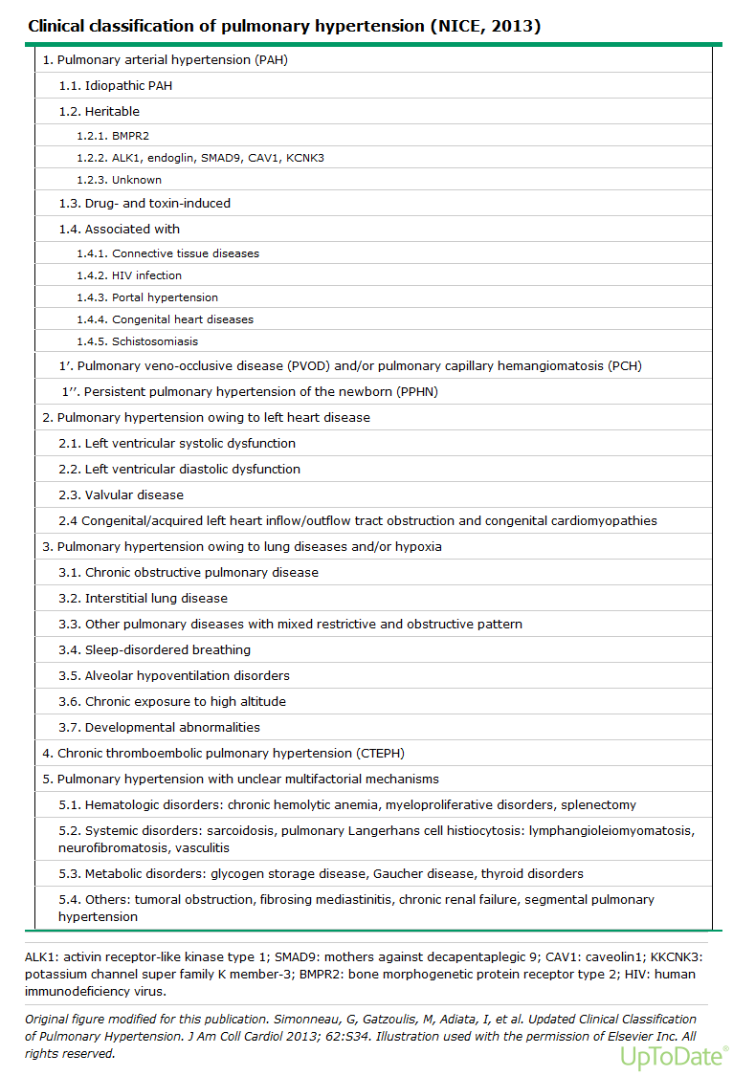
Pathogenesis:

- Group1 PAH is a proliferative vasculopathy of small muscular pulmonary arterioles characterized by medial hypertrophy, intimal hyperplasia as well as by plexiform lesions.
- Group 2-5 less understood and varied depending on the cause, but owing in part to vascular remodeling and increased pulmonary vascular resistance.

Clinical Manifestations:

- slow, insidious onset of vague symptoms such as exertional dyspnea, angina, fatigue, syncope, palpitations, peripheral edema
- Common PE findings: Increased intensity of pulmonic component of second heart sound, right ventricular heave, pulmonary TR murmur, signs of RV failure (raised JVP, hepatomegaly, ascites, peripheral edema, anasarca), cyanosis, or digital clubbing may be present.

Diagnosis:

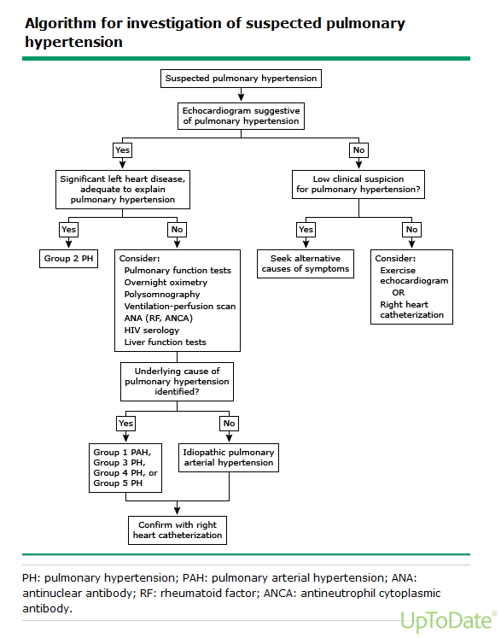
- RHC (gold standard): mPAP>25, PCWP<15, LVEDP<15
- If ILD is suspected, HRCT should be considered
- 6MWT to determine WHO functional class:

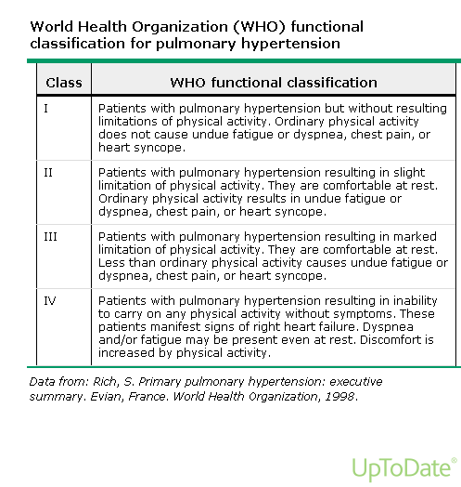

Treatment:

- The treatment of patients with group 1 pulmonary arterial hypertension (PAH) is different from that of the other groups who are, in general, less amenable to advanced
PAH-specific medical therapy. Primary therapy should be directed at the underlying cause of the PH.
- The disease severity should be reassessed following primary therapy, in order to determine whether advanced therapy is indicated.

All Groups:
- Several therapies should be considered in all groups with PH. These include diuretics, oxygen therapy (cornerstone therapy for group 3 PH), anticoagulation (indicated for all patients in group 4 and occasionally in patients in group 1), exercise training, and vaccinations
- A strict 4g sodium/1500ml fluid restriction diet should be followed in all patients.
- Patients should be aware of their “dry weight” and keep record of weights at home in order to detect signs of decompensated HF early.

Advanced Therapy:
- Often referred to as “pulmonary vasodilator therapy” is considered for patients who have WHO functional class II, III, or IV PHTN despite adequate primary therapy. It is widely used for patients with group 1 PAH and administered on case-by-case basis for groups 3-5 and in a few situations for group 2.
- Advanced therapy for group 1 PAH results in improved survival, 6MWT, functional class, and pulmonary hemodynamics, as well as delayed time to disease progression

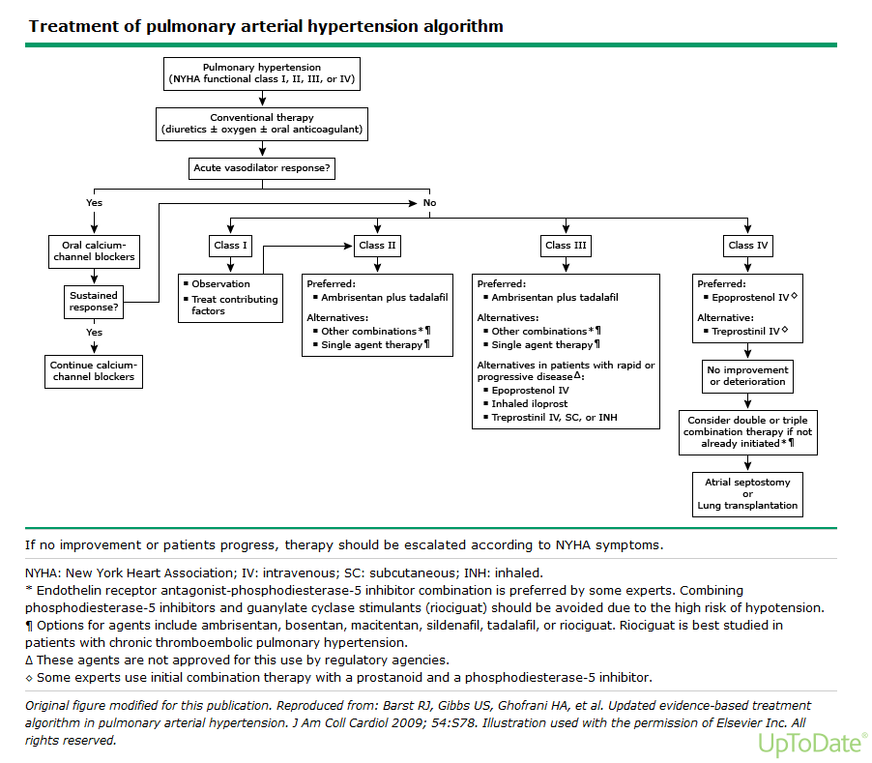
Group 2:
- Treatment of underlying heart disease directed under the care of a cardiologist.

Group 3:
- Treatment of the underlying cause of hypoxemia and correction of hypoxemia with supplemental oxygen.

Group 4:
- Anticoagulation is the primary medical therapy.
- Surgical thromboendarterectomy for selected patients.

