Chronic Liver Failure/Cirrhosis and ACLF
Definitions
Cirrhosis: Late stage of progressive hepatic fibrosis characterized by distortion of the hepatic
architecture and the formation of regenerative nodules. It is generally considered to be
irreversible in its advanced stages, at which point the only option may be liver transplantation
Acute on chronic liver failure (ACLF): Acute deterioration of pre-existing, chronic liver disease (cirrhosis) usually related to a preceding event and associated with an increased mortality at three months due to multi-system organ failure
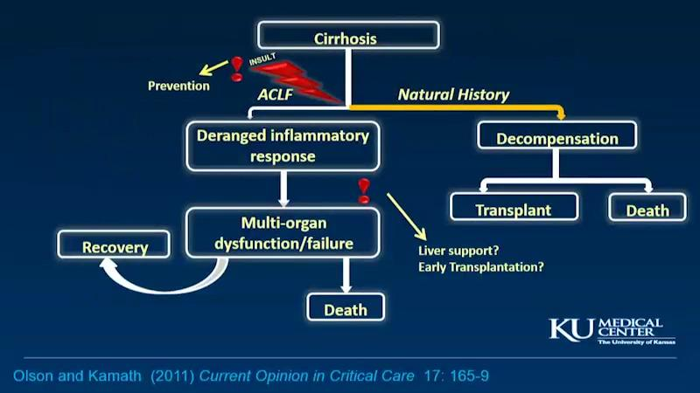
Characteristics
Cirrhosis:
- Progressive
- Not curable without transplant
- High morbidity and mortality
- Impacts QOL
- Must get worse before it gets better
ACLF:
- Cerebral edema is not a defining feature
- Occurs in pts with underlying cirrhosis
- Liver dysfunction may be partially reversible, but return to “normal” liver function may not be possible; a return to baseline (compensated cirrhosis) is possible
Causes
- Viral hepatitis (HCV is the most common)
- Alcohol
- Non-alcoholic fatty liver disease
- Autoimmune
- Primary biliary cirrhosis
- Primary sclerosing cholangitis
- Wilson disease
- Alpha-1 antitrypsin deficiency
- Hereditary hemochromatosis
- Other
Major Complications
- Hepatocellular carcinoma
- Portal Hypertension
  - Ascites
  - Hepatic encephalopathy
  - Variceal hemorrhage
  - Spontaneous bacterial peritonitis
  - Hepatorenal syndrome
  - Portal hypertensive gastropathy
  - Hepatic hydrothorax
  - Hepatopulmonary syndrome
  - Portopulmonary hypertension
  - Cirrhotic cardiomyopathy
Preventing Superimposed Liver Injury/Embarrassment
- Vaccinations: HAV, HBV, influenza, routine vaccinations
- Medication adjustment
- Minimize hepatotoxins
General Management
- Hepatitis C: Harvoni when stable (not during ACLF)
- Prevent manifestations of liver failure
- Provide temporary liver functions:
  - Mechanical devices
    - Plasma exchange (FPSA)
    - Albumin dialysis (ECAD, MARS)
  - Cell-based devices
    - Human cells (ELAD)
    - Porcine cells (HepatAssist)
Transplant evaluation
Stratifying risk for non-shunt operations: Child-Pugh classification
- Modification of the Child-Turcotte classification: Incorporated five variables that were designed to stratify the risk of portacaval shunt surgery in patients with cirrhosis, including serum albumin and bilirubin, ascites, encephalopathy, and nutritional status
- Child-Pugh classification replaces nutritional status with prothrombin time
- Score ranges from 5 to 15
  - Score of 5 or 6 = Child-Pugh class A cirrhosis (well-compensated cirrhosis)
  - Score of 7 to 9 have Child-Pugh class B cirrhosis (significant functional compromise)
  - Score of 10 to 15 have Child-Pugh class C cirrhosis (decompensated cirrhosis)
Stratifying risk for transplant surgery: Model for End-Stage Liver Disease (MELD)
- MELD > 15 : risk < benefit
0.957 x log e (creatinine mg/dL)
+ 0.378 x log e (bilirubin mg/dL)
+ 1.120 x log e (INR)
+ 0.643
Multiply by 10 and round to the nearest whole number
Range of 6-40

